

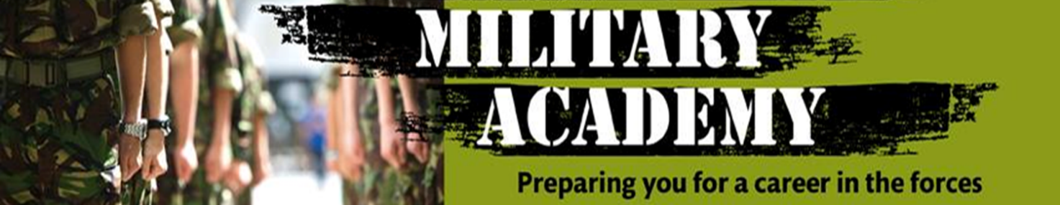



**Level 2 Diploma**

**for Entry to the**

**Uniformed Services**

**Unit 08 Carry out Map Reading and Navigation (L/505/9135)**

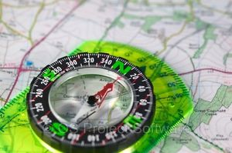

**Name: __________________________________________**

1. **Unit 8 of the Diploma is designed to give students a basic understanding of map reading and navigation. Now that you have looked through the basic information try and answer the questions below:**

**1.1. Give accurate 4 and 6 – figure grid references for a number of features on a map.**

**4 figure grid reference**

**Using the map above give a 4 figure grid reference for the locations below:**

* **Shatton = Grid reference =**
* **Thornhill = Grid reference =**
* **Bamford = Grid reference =**
* **Aston = Grid reference =**



* **Grid reference x 3 = 1)**

**2)**

**3)**

*  **Grid reference x 2 = 1)**

**2)**

1. **figure grid reference**



* **= Grid reference =**



* **= Grid reference =**
* **D = Grid reference =**
* **C = Grid reference =**

**1.2. Identify conventional symbols on Ordnance Survey maps.**

**Write down what you think they represent:**

**1. 2.**



**3. 4.**

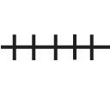



**Use the blank boxes to draw pictures of how you think the symbols for the following appear on a map:**

1. **Nature Reserve 6. Bus or Coach Station**

**7. Place of worship 8. Lighthouse**

**Use the blank boxes to draw pictures and label the other symbols that appear on a map:**

**9. ……………………………………………………. 10. ………………………………………**

**11. …………………………………………………. 12. ……………………………………..**

* 1. **Calculate distance on the ground by measuring distance on the map.**

Using the explorer map scale 1:25’000 work out the accurate distance of each of these routes.

* 1cm =250m
* Use string or paper

**C**

**B**

**D**

**A**